# C O M P 3 0 8 / S p r i n g 2 0 2 3 A S S I G N M E N T # 1

Q U E S T I O N S

# Q 1 ) C I R C U I T S W I T C H I N G [5x4 pts]

In the scenario below, imagine that you're sending an http request to another machine somewhere on the network. Consider the circuit-switched network shown in the figure below, with circuit switches A, B, C, and D. Suppose there are 14 circuits between A and B, 18 circuits between B and C, 12 circuits between C and D, and 15 circuits between D and A.

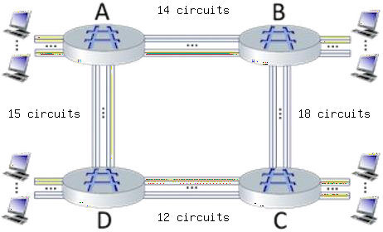

1. What is the maximum number of connections that can be ongoing in the network at any one time?

14+18+12+15 = 49

1. Suppose that these maximum number of connections are all ongoing. What happens when another call connection request arrives to the network, will it be accepted?

Answer Yes or No

No, it will be blocked since there are no free circuits.

1. Suppose that every connection requires 2 consecutive hops, and calls are connected clockwise. For example, a connection can go from A to C, from B to D, from C to A, and from D to B. With these constraints, what is the is the maximum number of connections that can be ongoing in the network at any one time?

A-C 🡪 14 / B-D 🡪 4 / C-A 🡪 8 / D-B 🡪0

Max = 14+4+8+0 = 26

1. Suppose that 13 connections are needed from A to C, and 10 connections are needed from B to D. Can we route these calls through the four links to accommodate all 23 connections? Answer Yes or No

Yes

# Q 2 ) C O M P U T I N G T H E O N E - H O P T R A N S M I S S I O N D E L AY

**[2.5x2 pts]**

Consider the figure below, in which a single router is transmitting packets, each of

length L bits, over a single link with transmission rate R Mbps to another router at the other end of the link.

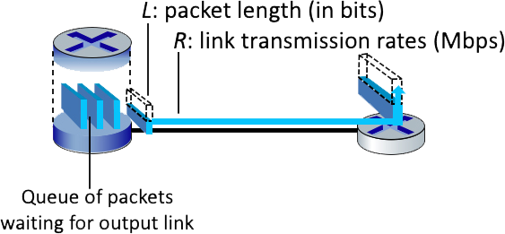

Suppose that the packet length is L= 8000 bits, and that the link transmission rate along the link to router on the right is R = 10 Mbps.

Round your answer to two decimals after leading zeros.

1. What is the transmission delay?

Transmission delay = Packet Delay (L) / Transmission Rate (R) = 0.0008 seconds

1. What is the maximum number of packets per second that can be transmitted by this link?

Maximum number of packers per second = R / L = 1250 per second

# Q 3 ) Q U A N T I T A T I V E C O M P A R I S O N O F P A C K E T S W I T C H I N G A N D C I R C U I T S W I T C H I N G [5x5 pts]

This question requires a little bit of background in probability (but we'll try to help you though it in the solutions). Consider the two scenarios below:

* + A circuit-switching scenario in which 𝑁𝑐𝑠 users, each requiring a bandwidth of 20 Mbps, must share a link of capacity 200 Mbps.
  + A packet-switching scenario with 𝑁𝑝𝑠 users sharing a 200 Mbps link, where each user again requires 20 Mbps when transmitting, but only needs to transmit 10 percent of the time.

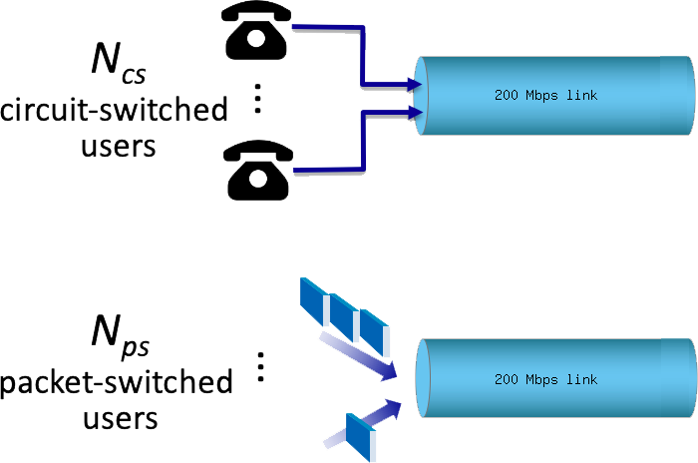

1. When circuit switching is used, what is the maximum number of users that can be supported?

200 Mbps / 20 Mbps = 10 users

1. Suppose packet switching is used. If there are 19 packet-switching users, can this many users be supported under circuit-switching? Yes or No.

No. Under circuit switching, only 10 users are able to use it.

1. Suppose packet switching is used. What is the probability that a given (specific) user is transmitting, and the remaining users are not transmitting?

Specific user (1 user) is transmitting, which can be denoted by p with probability of 0.1 and the others (18 users) are not transmitting, which can be denoted by (1-p) with probability of 0.9.

Total = 0.1 * (0.9) ^18 = 0.015

1. Suppose packet switching is used. What is the probability that one user (any one among the 19 users) is transmitting, and the remaining users are not transmitting?

Any of the users can be transmitting can be found with:

19*0.1*(0.9) ^18 = 0.29

1. What is the probability that more than 10 users are transmitting?

In order to find the probability that more than 10 users are transmitting, we need to calculate:

Sum [(19 chooses k)*((0.1)^k)*((0.9)^(19-k))] from 11 to 19

Result = 3.51*10^-7

# Q4) QUEUING DELAY[5x5 pts]

Consider the queuing delay in a router buffer, where the packet experiences a delay as it waits to be transmitted onto the link. The length of the queuing delay of a specific packet will depend on the number of earlier-arriving packets that are queued and waiting for transmission onto the link. If the queue is empty and no other packet is currently being transmitted, then our packet’s queuing delay will be zero. On the other hand, if the traffic is heavy and many other packets are also waiting to be transmitted, the queuing delay will be long.

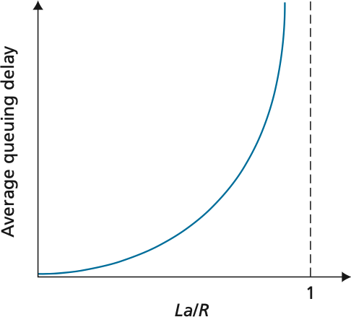

Assume a constant transmission rate of R = 1700000 bps, a constant packet-length L = 8500 bits, and a is the average rate of packets/second. Traffic intensity I = La/R, and the queuing delay is calculated as I(L/R) (1 - I) for I < 1.

1. In practice, does the queuing delay tend to vary a lot? Answer with Yes or No

Yes

1. Assuming that a = 22, what is the queuing delay? Give your answer in milliseconds (ms)

I = L*a/R = 8500 * 22/ 1700000 = 0.11

Delay = I*(L/R)*(1-I)*1000 = 0.4895 ms

1. Assuming that a = 65, what is the queuing delay? Give your answer in milliseconds (ms)

I = L*a/R = 8500 * 65/ 1700000 = 0.325

Delay = I*(L/R)*(1-I)*1000 = 1.0969 ms

1. Assuming the router's buffer is infinite, the queuing delay is 1.0969 ms, and 1619 packets arrive. How many packets will be in the buffer 1 second later?

Packets left in buffet = a – floor(1000/delay)

= 1619 – floor(1000/1.0969) = 707.3399 packets

1. If the buffer has a maximum size of 834 packets, how many of the 1619 packets would be dropped upon arrival from the previous question?

Packets dropped = packets – buffer size = 1619 – 834 = 785 packets will be dropped.

# Q5) END TO END THROUGHPUT AND BOTTLENECK LINKS [5x5 pts]

Consider the scenario shown below, with four different servers connected to four different clients over four three-hop paths. The four pairs share a common middle hop with a transmission capacity of R = 100 Mbps. The four links from the servers to the shared link have a transmission capacity of RS = 40 Mbps. Each of the four links from the shared middle link to a client has a transmission capacity of RC = 100 Mbps.

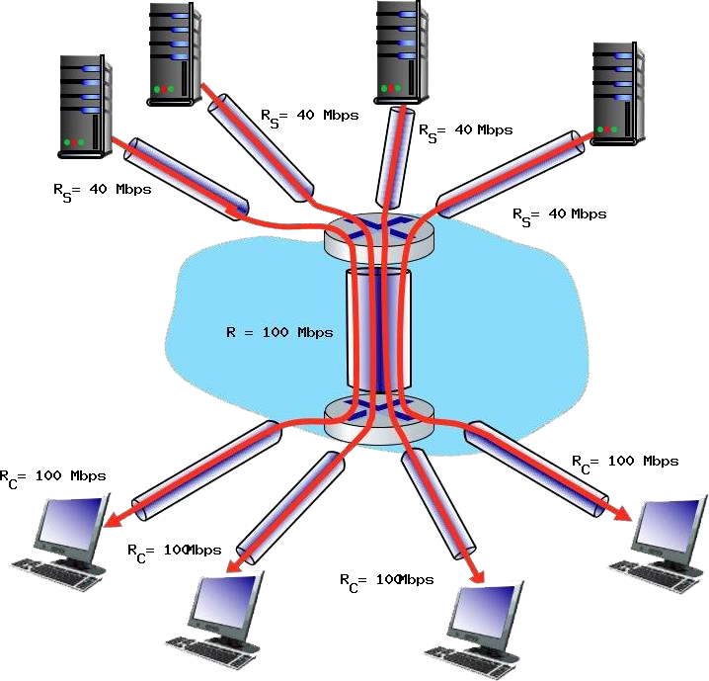

You might want to review Figure 1.20 in the textbook before answering the following questions.

1. What is the maximum achievable end-end throughput (in Mbps) for each of four client- to-server pairs, assuming that the middle link is fairly shared (divides its transmission rate equally)?

R/4 = 100Mbps/4 = 25 Mbps

1. Which link is the bottleneck link? Format as Rc, Rs, or R

Smallest between Rc = 100Mbp, Rs = 40Mbps, and R/4 = 25 Mbps

The bottleneck link is R.

1. Assuming that the servers are sending at the maximum rate possible, what are the link utilizations for the server links (RS)? Answer as a decimal

The server’s utilization = Rbottleneck / Rs = 25/40 = 0.625

1. Assuming that the servers are sending at the maximum rate possible, what are the link utilizations for the client links (RC)? Answer as a decimal

The client’s utilization = Rbottleneck / Rc = 25/100= 0.25

1. Assuming that the servers are sending at the maximum rate possible, what is the link utilizations for the shared link (R)? Answer as a decimal

The shared utilization = Rbottleneck / (R/4) = 25/(100/4) = 1